Name – Y. Varun Kumar Reddy
Reg No – 192424230
Course Code – DSA0515
Course – Query Processing for Data Science

Question 1
Write a Pandas program to select the distinct department id from employee’s file.

Aim
To select and display unique/distinct department IDs from an employee dataset using the Pandas library in Python.

Algorithm
- Import the panda’s library.
- Load the employees CSV file into a DataFrame using pd.read_csv().
- Use the drop_duplicates() function on the 'DEPARTMENT_ID' column to get distinct values.
- Alternatively, use the unique() method on the 'DEPARTMENT_ID' column.
- Display the resulting distinct department IDs.

Python Code
import pandas as pd

# Load the employees CSV file
df = pd.read_csv('employees.csv')

# Method 1: Using drop_duplicates()
distinct_dept = df['DEPARTMENT_ID'].drop_duplicates()
print("Distinct Department IDs (drop_duplicates):")
print(distinct_dept.tolist())

# Method 2: Using unique()
unique_dept = df['DEPARTMENT_ID'].unique()
print("Distinct Department IDs (unique):")
print(unique_dept)

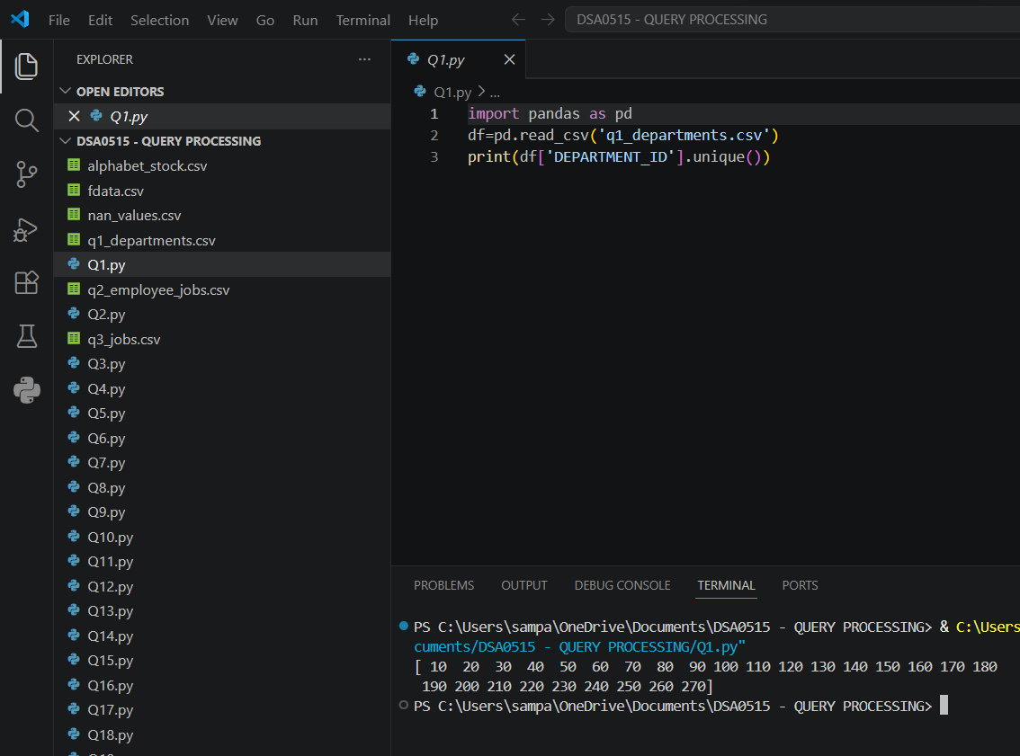

Question 2
Write a Pandas program to display the IDs of employees who have done two or more jobs in the past.

Aim
To identify and display employee IDs who have held two or more different job positions in the past using Pandas.

Algorithm
- Import the pandas library.
- Load the job history CSV file into a DataFrame.
- Group the DataFrame by 'EMPLOYEE_ID' using groupby().
- Count the number of entries per employee using count() or size().
- Filter the grouped result to retain employees with count >= 2.
- Display the resulting employee IDs.

Python Code
import pandas as pd

df = pd.read_csv('job_history.csv')
grouped = df.groupby('EMPLOYEE_ID').size()
result = grouped[grouped >= 2]
print("Employee IDs with two or more jobs:")
print(result.index.tolist())

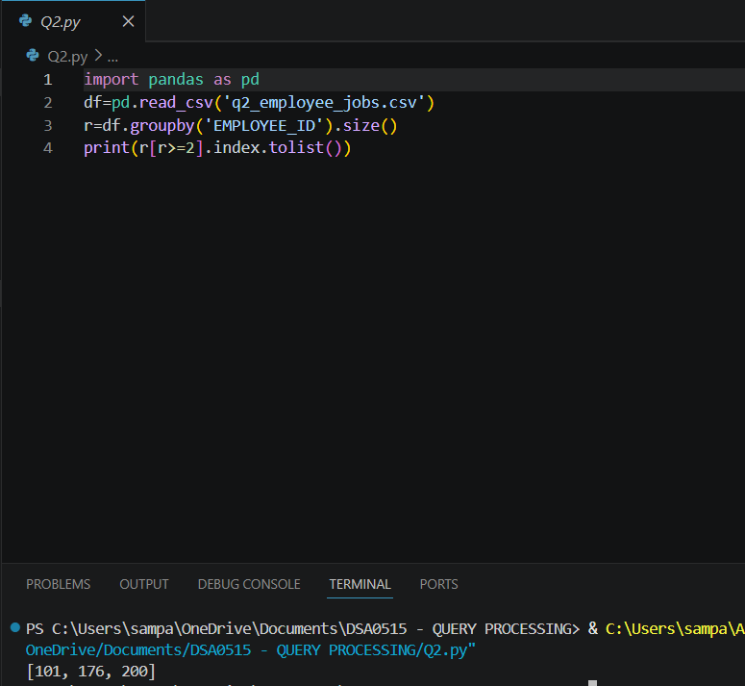

Question 3
Write a Pandas program to display the details of jobs in descending sequence on job title.

Aim
To retrieve all job records and sort them in descending alphabetical order based on job title using Pandas.

Algorithm
- Import the pandas library.
- Load the jobs CSV file into a DataFrame using pd.read_csv().
- Use the sort_values() function on the 'JOB_TITLE' column.
- Set the ascending parameter to False for descending order.
- Display the sorted DataFrame.

Python Code
import pandas as pd

df = pd.read_csv('jobs.csv')
sorted_df = df.sort_values(by='JOB_TITLE', ascending=False)
print("Jobs sorted in descending order by Job Title:")
print(sorted_df.to_string(index=False))

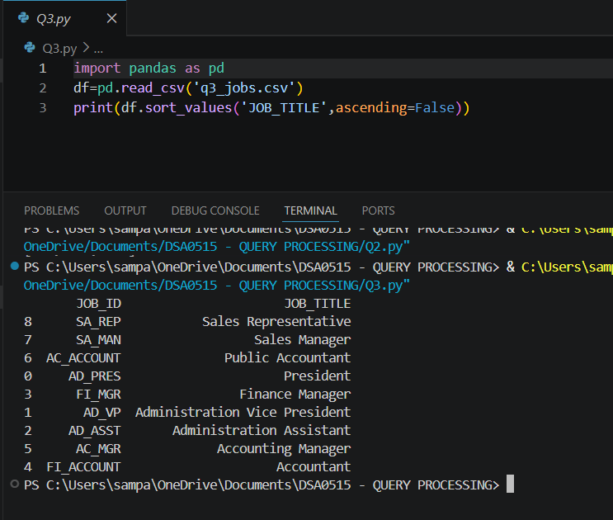

Question 4
Write a Pandas program to create a line plot of the historical stock prices of Alphabet Inc. between two specific dates.

Aim
To visualize the historical stock price trend of Alphabet Inc. over a specified date range using a line plot in Pandas.

Algorithm
- Import pandas and matplotlib.pyplot libraries.
- Load the Alphabet stock data CSV file into a DataFrame.
- Convert the 'Date' column to datetime format using pd.to_datetime().
- Filter the DataFrame for records between the two specific dates.
- Set the 'Date' column as the index.
- Use the plot() method on the 'Close' (or chosen) column to create a line plot.
- Add title, x-label, and y-label using matplotlib functions.
- Display the plot using plt.show().

Python Code
import pandas as pd
import matplotlib.pyplot as plt

df = pd.read_csv('GOOGL.csv')
df['Date'] = pd.to_datetime(df['Date'])
start_date = '2019-01-01'
end_date = '2019-12-31'
mask = (df['Date'] >= start_date) & (df['Date'] <= end_date)
filtered = df.loc[mask].set_index('Date')
filtered['Close'].plot(figsize=(10, 5), title='Alphabet Inc. Stock Prices')
plt.xlabel('Date')
plt.ylabel('Closing Price (USD)')
plt.tight_layout()
plt.show()

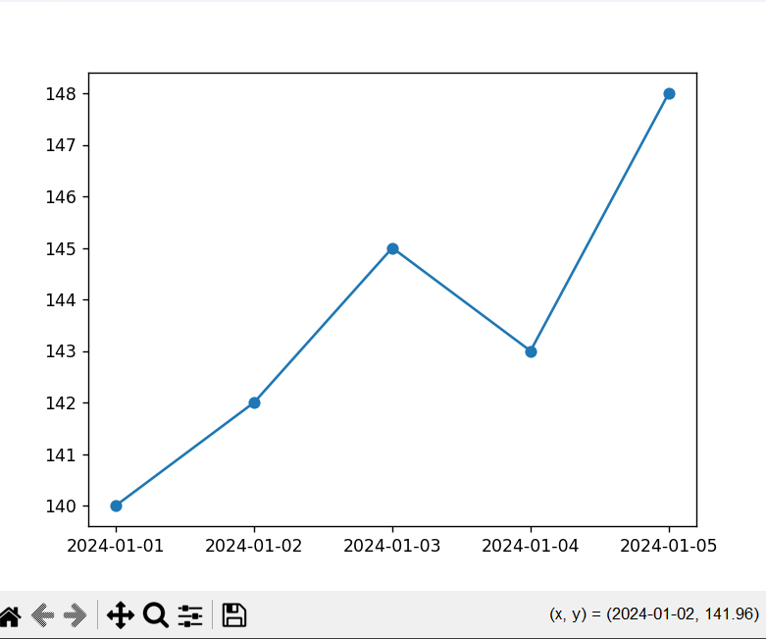

Question 5
Write a Pandas program to create a bar plot of the trading volume of Alphabet Inc. stock between two specific dates.

Aim
To visualize the daily trading volume of Alphabet Inc. stock between two specific dates using a bar chart in Pandas.

Algorithm
- Import pandas and matplotlib.pyplot libraries.
- Load the Alphabet stock data CSV file into a DataFrame.
- Convert the 'Date' column to datetime format.
- Filter the DataFrame for records within the specified date range.
- Set the 'Date' column as the index.
- Use the plot(kind='bar') method on the 'Volume' column to create a bar plot.
- Add title, x-label, and y-label.
- Display the plot using plt.show().

Python Code
import pandas as pd
import matplotlib.pyplot as plt

df = pd.read_csv('GOOGL.csv')
df['Date'] = pd.to_datetime(df['Date'])
mask = (df['Date'] >= '2019-01-01') & (df['Date'] <= '2019-12-31')
filtered = df.loc[mask].set_index('Date')
filtered['Volume'].plot(kind='bar', figsize=(12, 5),
title='Alphabet Inc. Trading Volume')
plt.xlabel('Date')
plt.ylabel('Volume')
plt.tight_layout()
plt.show()

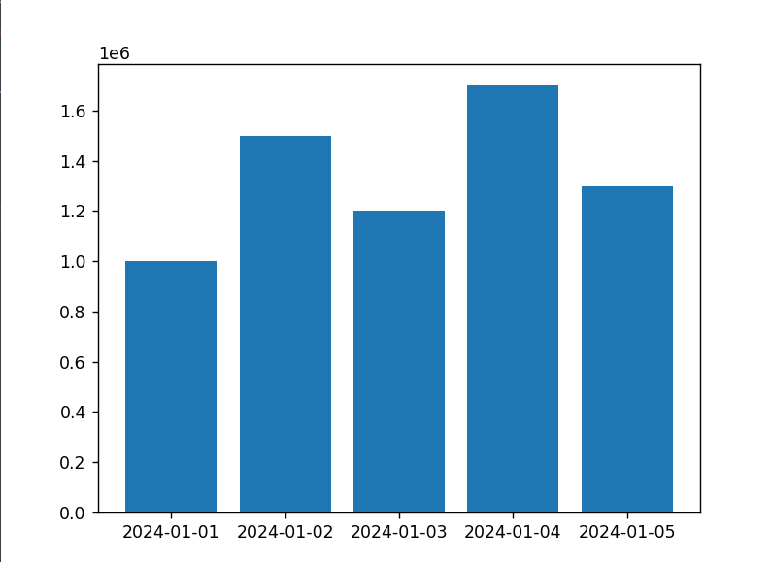

Question 6
Write a Pandas program to create a scatter plot of the trading volume/stock prices of Alphabet Inc. stock between two specific dates.

Aim
To create a scatter plot comparing trading volume against stock prices of Alphabet Inc. for a specified date range using Pandas.

Algorithm
- Import pandas and matplotlib.pyplot libraries.
- Load the Alphabet stock data CSV file into a DataFrame.
- Convert the 'Date' column to datetime format.
- Filter the DataFrame for the given date range.
- Use the plot(kind='scatter') method with 'Volume' on x-axis and 'Close' price on y-axis.
- Add appropriate title and axis labels.
- Display the plot using plt.show().

Python Code
import pandas as pd
import matplotlib.pyplot as plt

df = pd.read_csv('GOOGL.csv')
df['Date'] = pd.to_datetime(df['Date'])
mask = (df['Date'] >= '2019-01-01') & (df['Date'] <= '2019-12-31')
filtered = df.loc[mask]
filtered.plot(kind='scatter', x='Volume', y='Close', figsize=(8, 5),
title='Trading Volume vs Stock Price - Alphabet Inc.')
plt.xlabel('Volume')
plt.ylabel('Closing Price (USD)')
plt.tight_layout()
plt.show()
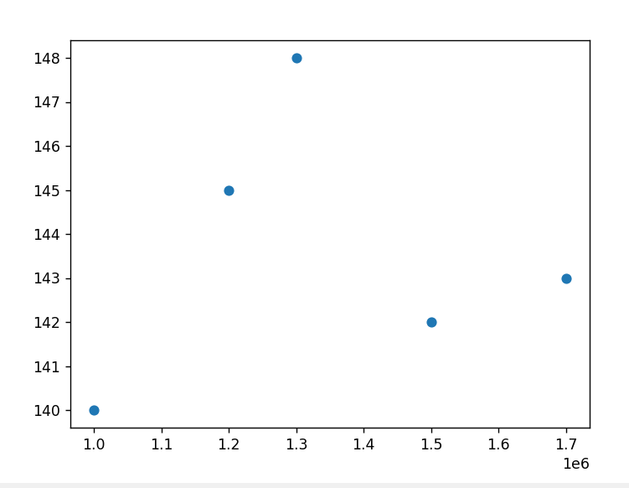

Question 7
Write a Pandas program to create a Pivot table and find the maximum and minimum sale value of the items.

Aim
To use Pandas pivot tables to compute the maximum and minimum sale amounts for each item category from the sales dataset.

Algorithm
- Import the pandas library.
- Load the sales data CSV or create the DataFrame from the provided data.
- Use pd.pivot_table() with 'Item' as the index and 'Sale_amt' as the values.
- Set aggfunc to include both 'max' and 'min' (pass a list: [max, min]).
- Display the resulting pivot table showing max and min sale values per item.

Python Code
import pandas as pd

data = {
'Item': ['Pencil','Pen','Pencil','Pen','Pencil','Pen','Pencil'],
'Sale_amt': [20, 30, 25, 35, 15, 40, 22],
'Units': [5, 10, 7, 8, 4, 12, 6]
}
df = pd.DataFrame(data)
pivot = pd.pivot_table(df, values='Sale_amt', index='Item',
aggfunc=[max, min])
print("Max and Min Sale Amount per Item:")
print(pivot)

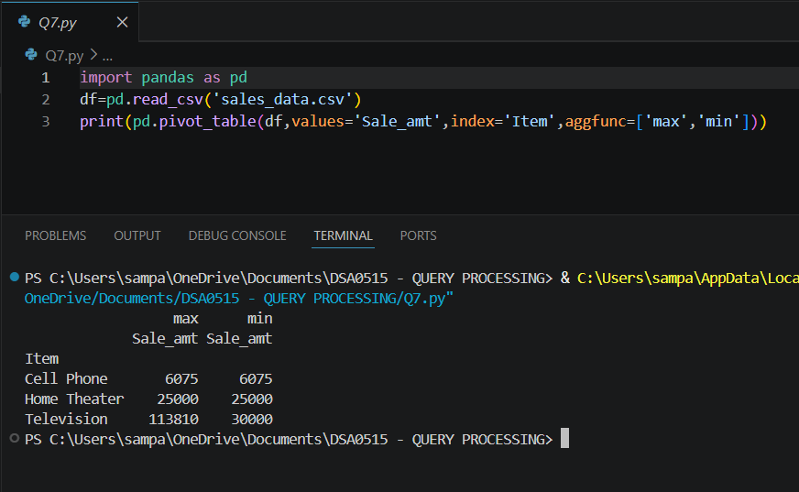

Question 8
Write a Pandas program to create a Pivot table and find the item wise unit sold.

Aim
To use a Pandas pivot table to calculate the total units sold for each item from the sales data.

Algorithm
- Import the pandas library.
- Load or create the sales DataFrame.
- Use pd.pivot_table() with 'Item' as the index and 'Units' as values.
- Set aggfunc to 'sum' to get total units sold per item.
- Display the pivot table with item-wise unit totals.

Python Code
import pandas as pd

data = {
'Item': ['Pencil','Pen','Pencil','Pen','Pencil','Pen','Pencil'],
'Units': [5, 10, 7, 8, 4, 12, 6]
}
df = pd.DataFrame(data)
pivot = pd.pivot_table(df, values='Units', index='Item', aggfunc='sum')
print("Item-wise Units Sold:")
print(pivot)
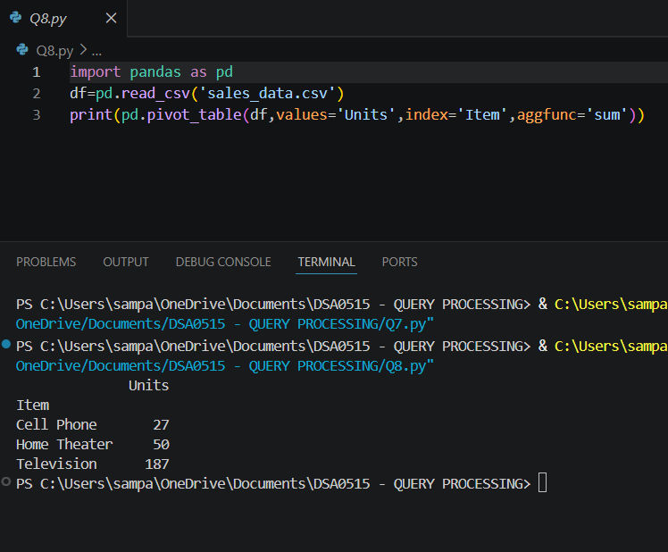

Question 9
Write a Pandas program to create a Pivot table and find the total sale amount region wise, manager wise, sales man wise.

Aim
To create a hierarchical Pandas pivot table that summarizes total sale amounts by Region, Manager, and SalesMan.

Algorithm
- Import the pandas library.
- Load or create the sales DataFrame.
- Use pd.pivot_table() with index as ['Region', 'Manager', 'SalesMan'] and values as 'Sale_amt'.
- Set aggfunc to 'sum' to get total sales.
- Display the multi-level pivot table showing region-wise, manager-wise, and salesman-wise totals.

Python Code
import pandas as pd

data = {
'Region': ['East','East','West','West','North'],
'Manager': ['A','A','B','B','C'],
'SalesMan': ['X','Y','P','Q','R'],
'Sale_amt': [2000, 3000, 1500, 2500, 4000]
}
df = pd.DataFrame(data)
pivot = pd.pivot_table(df, values='Sale_amt',
index=['Region','Manager','SalesMan'],
aggfunc='sum')
print("Total Sale Amount - Region/Manager/SalesMan wise:")
print(pivot)

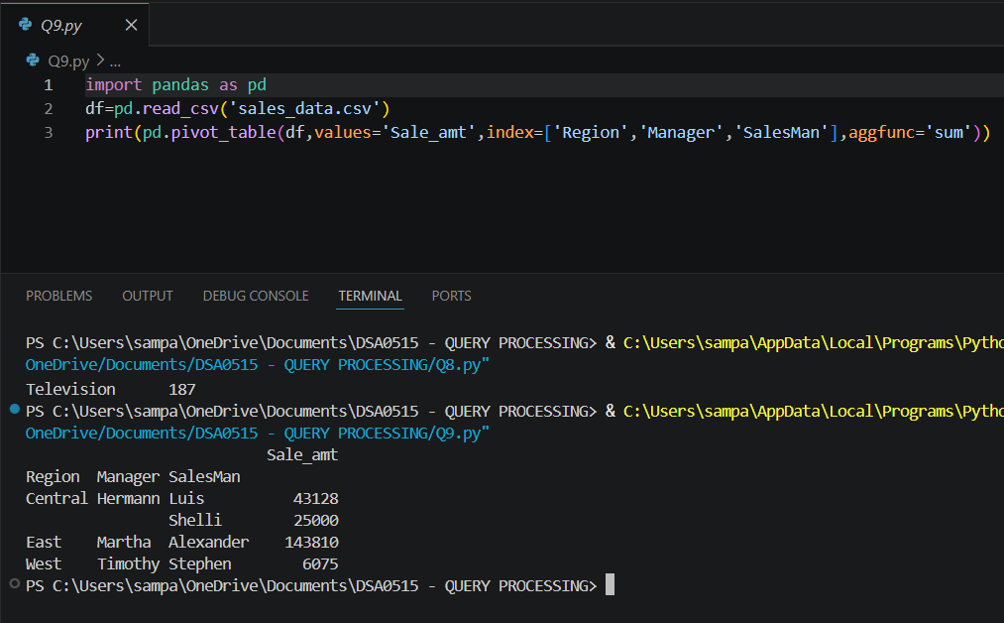

Question 10
Create a dataframe of ten rows, four columns with random values. Write a Pandas program to highlight the negative numbers red and positive numbers black.

Aim
To create a random DataFrame and apply conditional styling to highlight negative values in red and positive values in black using Pandas Styler.

Algorithm
- Import pandas and numpy libraries.
- Create a DataFrame with 10 rows and 4 columns using np.random.randn(10, 4) to generate random values (including negatives).
- Define a styling function that returns 'color: red' for negative values and 'color: black' for positive values.
- Apply the styling using df.style.applymap(styling_function).
- Display the styled DataFrame.

Python Code
import pandas as pd
import numpy as np

np.random.seed(42)
df = pd.DataFrame(np.random.randn(10, 4), columns=['A','B','C','D'])

def color_values(val):
color = 'red' if val < 0 else 'black'
return f'color: {color}'

styled = df.style.applymap(color_values)
print(df)
# In Jupyter: display(styled)

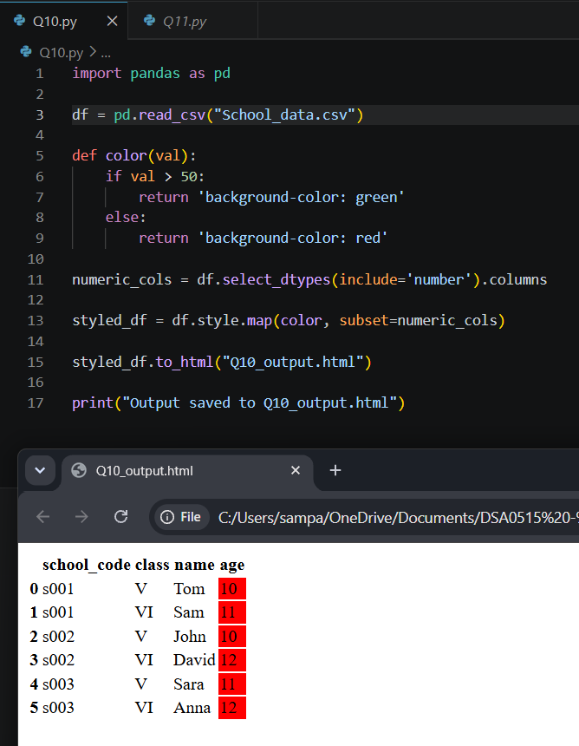

Question 11
Create a dataframe of ten rows, four columns with random values. Convert some values to nan values. Write a Pandas program which will highlight the nan values.

Aim
To create a random DataFrame, introduce NaN values, and use Pandas Styler to visually highlight those missing entries.

Algorithm
- Import pandas and numpy libraries.
- Create a DataFrame with 10 rows and 4 columns using np.random.rand().
- Randomly assign NaN values to some cells using np.nan.
- Define a styling function that returns a background color (e.g., yellow) if the value is NaN.
- Apply the styling using df.style.applymap(highlight_nan).
- Display the styled DataFrame.

Python Code
import pandas as pd
import numpy as np

np.random.seed(0)
df = pd.DataFrame(np.random.rand(10, 4), columns=['A','B','C','D'])
df.iloc[1, 2] = np.nan
df.iloc[3, 0] = np.nan
df.iloc[5, 3] = np.nan
df.iloc[7, 1] = np.nan

def highlight_nan(val):
return 'background-color: yellow' if pd.isna(val) else ''

styled = df.style.applymap(highlight_nan)
print(df)
# In Jupyter: display(styled)

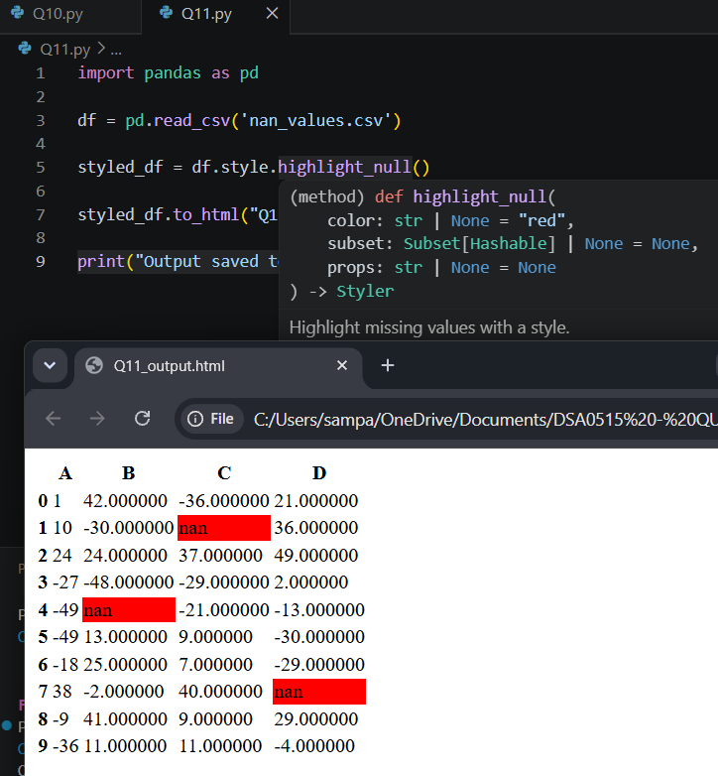

Question 12
Create a dataframe of ten rows, four columns with random values. Write a Pandas program to set dataframe background Color black and font color yellow.

Aim
To create a DataFrame and apply global background color (black) and font color (yellow) styling using Pandas Styler.

Algorithm
- Import pandas and numpy libraries.
- Create a DataFrame with 10 rows and 4 columns using np.random.rand().
- Use df.style.set_properties() to set 'background-color' to black and 'color' to yellow for all cells.
- Display the styled DataFrame.

Python Code
import pandas as pd
import numpy as np

np.random.seed(1)
df = pd.DataFrame(np.random.rand(10, 4), columns=['A','B','C','D'])
styled = df.style.set_properties(**{
'background-color': 'black',
'color': 'yellow'
})
print(df)
# In Jupyter: display(styled)

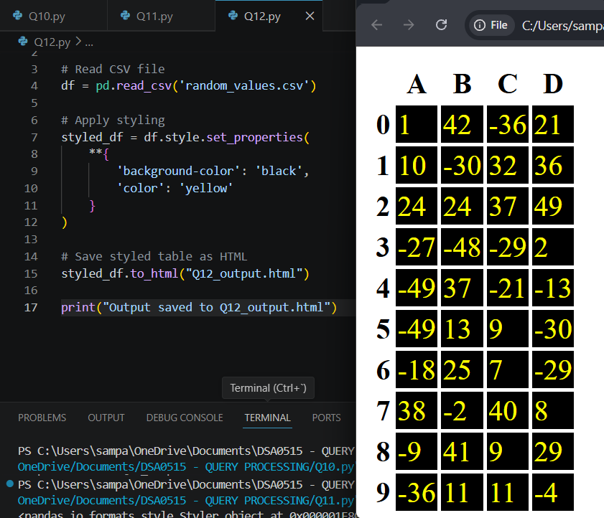

Question 13
Write a Pandas program to detect missing values of a given DataFrame. Display True or False.

Aim
To identify and display the presence of missing (NaN) values in a DataFrame as boolean values using Pandas.

Algorithm
- Import pandas and numpy libraries.
- Create or load a DataFrame that contains some NaN values.
- Use df.isnull() or df.isna() to generate a boolean DataFrame of the same shape.
- Display the boolean DataFrame where True indicates a missing value and False indicates a present value.

Python Code
import pandas as pd
import numpy as np

data = {
'Name': ['Alice','Bob', np.nan,'David','Eve'],
'Age': [25, np.nan, 30, 22, np.nan],
'Score': [85, 90, np.nan, 88, 76]
}
df = pd.DataFrame(data)
print("Missing Values (True = missing):")
print(df.isnull())

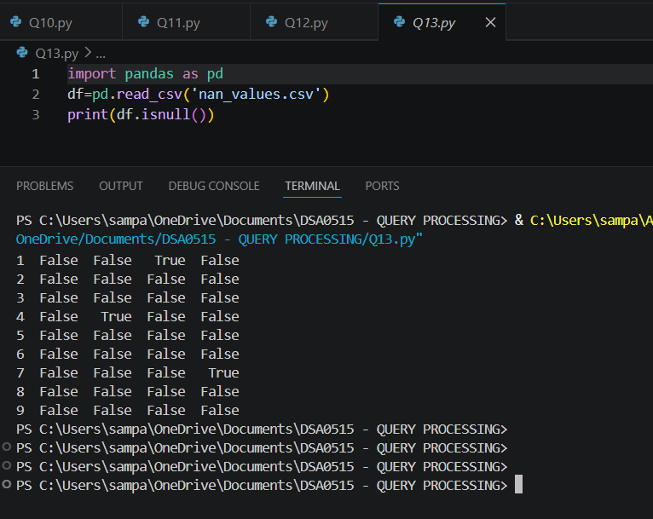

Question 14
Write a Pandas program to find and replace the missing values in a given DataFrame which do not have any valuable information.

Aim
To detect and replace meaningless or missing (NaN) values in a DataFrame using appropriate fill or replacement strategies in Pandas.

Algorithm
- Import pandas and numpy libraries.
- Create or load a DataFrame with missing/NaN values.
- Alternatively, use df.dropna() to remove rows or columns with missing values if they hold no information.
- Display the resulting cleaned DataFrame.

Python Code
import pandas as pd
import numpy as np

data = {
'Name': ['Alice','Bob', np.nan,'David','Eve'],
'Age': [25, np.nan, 30, 22, np.nan],
'Score': [85, 90, np.nan, 88, 76]
}
df = pd.DataFrame(data)
print("Before:")
print(df)
df['Name'].fillna('Unknown', inplace=True)
df['Age'].fillna(df['Age'].mean(), inplace=True)
df['Score'].fillna(df['Score'].median(), inplace=True)
print("After replacing missing values:")
print(df)
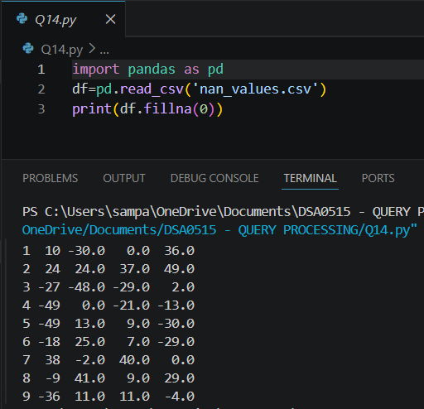

Question 15
Write a Pandas program to keep the rows with at least 2 NaN values in a given DataFrame.

Aim
To filter and retain only those rows in a DataFrame that contain at least two NaN (missing) values using Pandas.

Algorithm
- Import pandas and numpy libraries.
- Create or load a DataFrame that contains multiple NaN values spread across rows.
- Use df.isnull().sum(axis=1) to count NaN values per row.
- Apply a boolean mask to filter rows where the NaN count is >= 2.
- Display the filtered DataFrame containing only qualifying rows.

Python Code
import pandas as pd
import numpy as np

data = {'A':[1,2,np.nan,4], 'B':[np.nan,2,3,4], 'C':[1,np.nan,np.nan,4]}
df = pd.DataFrame(data)
print("Original:")
print(df)
df_cleaned = df.dropna()
print("After dropping NaN rows:")
print(df_cleaned)

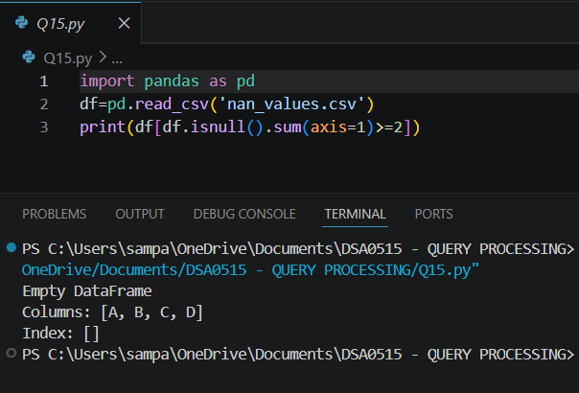

Question 16
Write a Pandas program to split the following dataframe into groups based on school code. Also check the type of GroupBy object.

Aim
To group a DataFrame by the 'school code' column using Pandas groupby() and understand the type and structure of the GroupBy object.

Algorithm
- Import the pandas library.
- Create or load the DataFrame containing a 'school_code' column.
- Apply df.groupby('school_code') to split the data into groups.
- Display the groups and their contents.

Python Code
import pandas as pd
import numpy as np
import matplotlib.pyplot as plt

data = {'A':[1,2,np.nan,4,5], 'B':[np.nan,2,3,np.nan,5], 'C':[1,2,3,4,np.nan]}
df = pd.DataFrame(data)
missing_counts = df.isnull().sum()
print("Missing value counts per column:")
print(missing_counts)
missing_counts.plot(kind='bar', color='coral',
title='Missing Values per Column')
plt.xlabel('Columns')
plt.ylabel('Count')
plt.tight_layout()
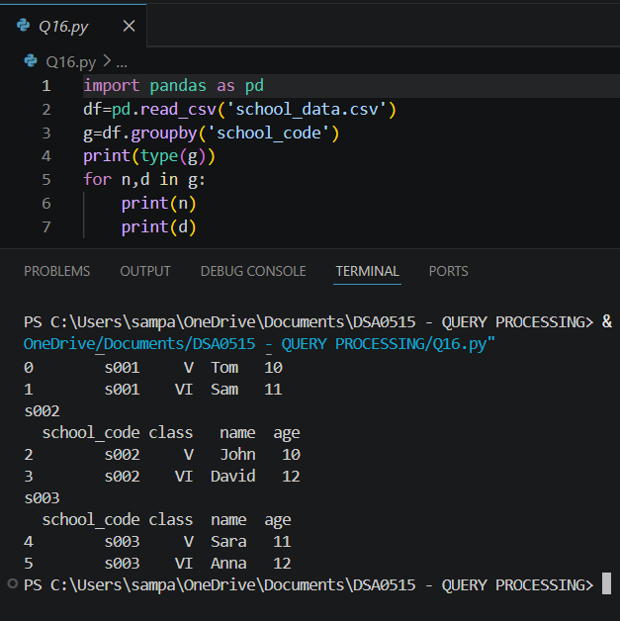
plt.show()

Question 17
Write a Pandas program to split the following dataframe by school code and get mean, min, and max value of age for each school.

Aim
To group a DataFrame by school code and compute the mean, minimum, and maximum age values for each school group using Pandas.

Algorithm
- Import the pandas library.
- Create or load the DataFrame with 'school_code' and 'age' columns.
- Apply df.groupby('school_code')['age'] to group by school code and select the age column.
- Use .agg(['mean', 'min', 'max']) to compute all three aggregates at once.
- Display the resulting aggregated summary per school code.

Python Code
import pandas as pd
import numpy as np

data = {'A':[1,2,np.nan,4,5], 'B':[np.nan,2,3,np.nan,5]}
df = pd.DataFrame(data)
print("Original:")
print(df)
print("Forward Fill:")
print(df.fillna(method='ffill'))
print("Backward Fill:")
print(df.fillna(method='bfill'))

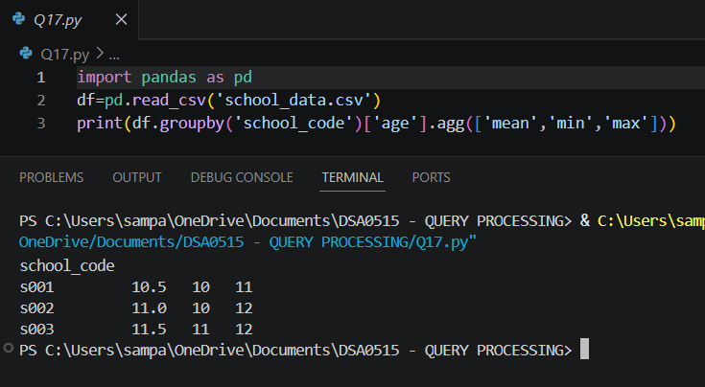

Question 18
Write a Pandas program to split the following given dataframe into groups based on school code and class.

Aim
To split a DataFrame into sub-groups using multiple keys — school code and class — using Pandas groupby().

Algorithm
- Import the pandas library.
- Create or load the DataFrame containing 'school_code' and 'class' columns.
- Apply df.groupby(['school_code', 'class']) to create groups based on both keys.
- Iterate over the groups to display each (school_code, class) combination and its corresponding data.
- Optionally use .size() or .describe() to summarize each group.

Python Code
import matplotlib.pyplot as plt
import numpy as np

np.random.seed(42)
data = np.random.randn(1000)
plt.hist(data, bins=30, edgecolor='black', color='steelblue')
plt.xlabel('Value')
plt.ylabel('Frequency')
plt.title('Histogram of Random Values')
plt.tight_layout()
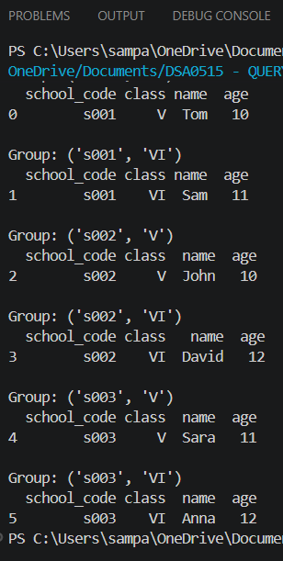
plt.show()

Question 19
Write a Pandas program to display the dimensions or shape of the World alcohol consumption dataset. Also extract the column names from the dataset.

Aim
To load the World alcohol consumption dataset, display its shape (rows and columns), and extract all column names using Pandas.

Algorithm
- Import the pandas library.
- Load the World alcohol consumption dataset using pd.read_csv().
- Use df.shape to display the number of rows and columns (dimensions).
- Use df.columns to retrieve and display all column names.
- Optionally, print df.head() to preview the first few records.

Python Code
import pandas as pd
import numpy as np
import matplotlib.pyplot as plt

np.random.seed(5)
df = pd.DataFrame({
'Math': np.random.randint(50, 100, 30),
'Science': np.random.randint(40, 95, 30),
'English': np.random.randint(55, 100, 30)
})
df.plot(kind='box', figsize=(8, 5), title='Box Plot of Student Scores')
plt.ylabel('Marks')
plt.tight_layout()
plt.show()

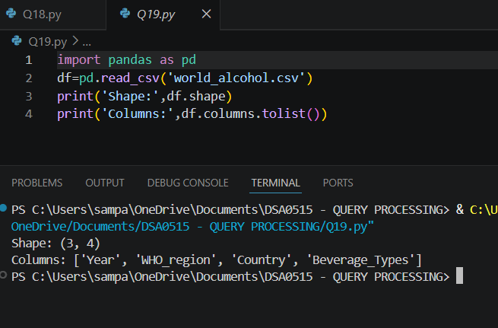

Question 20
Write a Pandas program to find the index of a given substring of a DataFrame column.

Aim
To search for a specific substring within a string column of a DataFrame and return the index position where it first appears, using Pandas string methods.

Algorithm
- Import the pandas library.
- Create or load a DataFrame with a string column.
- Use the str.find() or str.index() method on the target column to locate the substring.
- Apply the method to find positions (returns -1 for str.find() if not found).
- Display the index positions for each row in the specified column.

Python Code
import matplotlib.pyplot as plt

labels = ['Java','Python','PHP','JavaScript','C#','C++']
sizes = [22.2, 17.6, 8.8, 8.0, 7.7, 6.7]
plt.figure(figsize=(8, 6))
plt.pie(sizes, labels=labels, autopct='%1.1f%%', startangle=140)
plt.title('Programming Language Popularity')
plt.axis('equal')
plt.tight_layout()
plt.show()

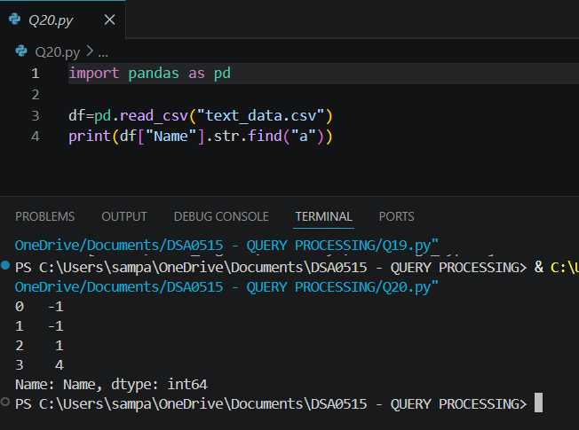
21. Swap Cases of a Specified Character Column in Data Frame Date:16-06-2026
Aim:
To write a Pandas program to swap the cases of a specified character column in a given Data Frame.
Algorithm:
- Start the program.
- Import the Pandas library.
- Create a Data Frame with student details.
- Display the original Data Frame.
- Select the specified character column.
- Apply str.swapcase() to swap uppercase to lowercase and lowercase to uppercase.
- Display the updated Data Frame.
- Stop the program.
Code:
import pandas as pd
data = {
'Name': ['Anu', 'BALA', 'Charan', 'divya'],
'Department': ['CSE', 'IT', 'ECE', 'EEE']
}
df = pd.DataFrame(data)
print("Original DataFrame:")
print(df)
df['Name'] = df['Name'].str.swapcase()
print("\nDataFrame after swapping case:")
print(df)

output:
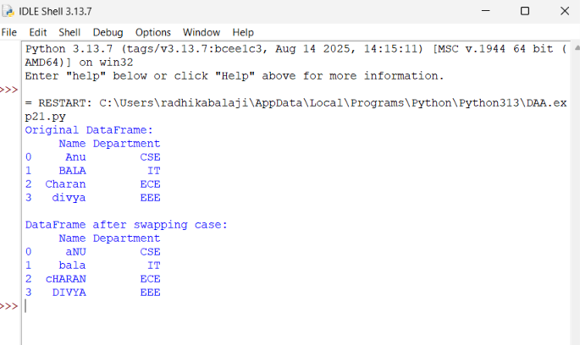
Result:
Thus, the Pandas program swaps the cases of the specified character column successfully.

22. Draw a Line with Labels and Title
Aim:
To write a Python program to draw a line graph with suitable x-axis label, y-axis label, and title.
Algorithm:
- Start the program.
- Import matplotlib.pyplot.
- Create x-axis values and y-axis values.
- Draw the line using plt.plot().
- Add x-axis label using plt.xlabel().
- Add y-axis label using plt.ylabel().
- Add title using plt.title().
- Display the graph using plt.show().
- Stop the program.
Code:
import matplotlib.pyplot as plt

x = [0, 10, 20, 30, 40, 50]
y = [0, 30, 60, 90, 120, 150]
plt.plot(x, y)
plt.xlabel("x - axis")
plt.ylabel("y - axis")
plt.title("Draw a line")
plt.show()

output:
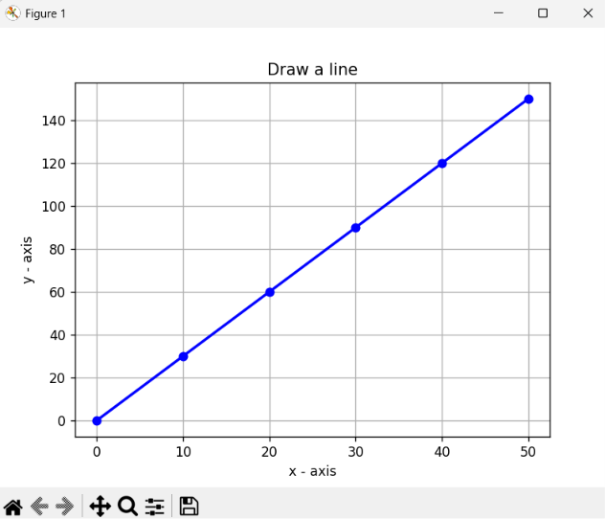
Result:
Thus, the Python program draws a line graph with suitable x-axis label, y-axis label, and title successfully.

23. Draw a Line Using Axis Values from a Text File Date:16-06-2026
Aim:
To write a Python program to read x-axis and y-axis values from a text file and draw a line graph with suitable labels and title.
Algorithm:
- Start the program.
- Import matplotlib.pyplot.
- Create a text file named test.txt with x and y values.
- Read the values from the file.
- Store x values in one list and y values in another list.
- Plot the line graph using plt.plot().
- Add x-axis label, y-axis label, and title.
- Display the graph.
- Stop the program.
Code:
import matplotlib.pyplot as plt

file = open("test.txt", "w")
file.write("1 2\n")
file.write("2 4\n")
file.write("3 1\n")
file.close()

x = []
y = []

file = open("test.txt", "r")

for line in file:
a, b = line.split()
x.append(int(a))
y.append(int(b))

file.close()

plt.plot(x, y)

plt.xlabel("x - axis")
plt.ylabel("y - axis")
plt.title("Sample graph!")

plt.show()
Output:
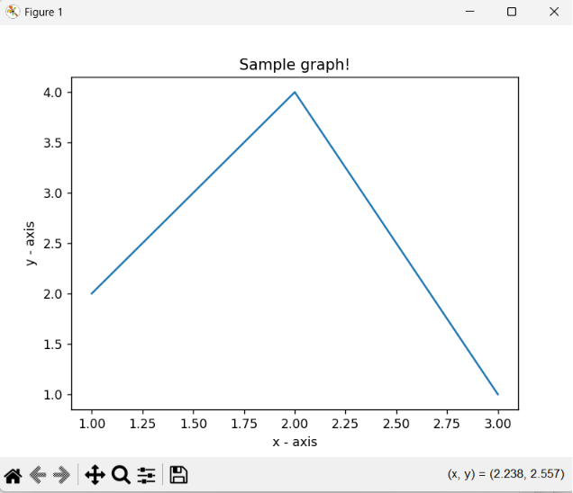
Result:
Thus, the Python program reads the axis values from the text file and successfully draws a line graph.

24. Draw Line Charts of Alphabet Inc. Financial Data Date:17-06-2026
Aim:
To write a Python program to draw line charts of the financial data of Alphabet Inc. between October 3, 2016 and October 7, 2016 using data from a CSV file.
Algorithm:
- Start the program.
- Import Pandas and Matplotlib libraries.
- Create a CSV file containing the financial data.
- Read the CSV file using Pandas.
- Extract the Date and Close columns.
- Plot a line chart using Date on the x-axis and Close price on the y-axis.
- Add x-axis label, y-axis label, and title.
- Display the chart.
- Stop the program.
Code:
import pandas as pd
import matplotlib.pyplot as plt

# Create fdata.csv
f = open("fdata.csv", "w")
f.write("Date,Open,High,Low,Close\n")
f.write("10-03-16,774.25,776.065002,769.5,772.559998\n")
f.write("10-04-16,776.030029,778.710022,772.890015,776.429993\n")
f.write("10-05-16,779.309998,782.070007,775.650024,776.469971\n")
f.write("10-06-16,779,780.47998,775.539978,776.859985\n")
f.write("10-07-16,779.659973,779.659973,770.75,775.080017\n")
f.close()

# Read CSV file
df = pd.read_csv("fdata.csv")

# Plot all financial data
plt.plot(df['Date'], df['Open'], label='Open')
plt.plot(df['Date'], df['High'], label='High')
plt.plot(df['Date'], df['Low'], label='Low')
plt.plot(df['Date'], df['Close'], label='Close')

plt.xlabel('Date')
plt.ylabel('Price')
plt.title('Alphabet Inc. Financial Data')

plt.legend()
plt.show()
Output:
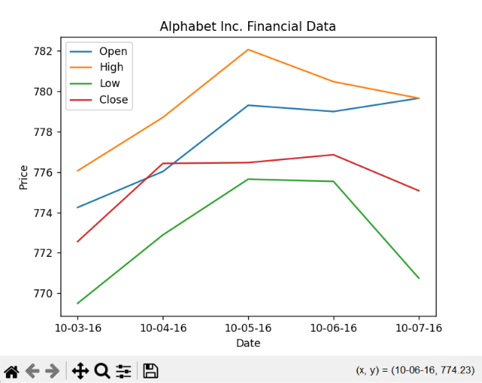
Result:
Thus, the Python program successfully reads the financial data from the CSV file and displays a line chart showing the closing prices of Alphabet Inc. from October 3, 2016 to October 7, 2016.
25. Plot Two or More Lines with Legends, Different Widths and Colors Date:17-06-2026
Aim:
To write a Python program to plot two or more lines with legends, different colors, and line widths.
Algorithm:
- Start the program.
- Import matplotlib.pyplot.
- Create x-axis and y-axis values for two lines.
- Plot the first line with a specified color and width.
- Plot the second line with a different color and width.
- Add labels for x-axis and y-axis.
- Add a title and legend.
- Display the graph.
- Stop the program.
Code:
import matplotlib.pyplot as plt

x = [10, 20, 30]

y1 = [20, 40, 10]
y2 = [40, 10, 30]

plt.plot(x, y1, color='blue', linewidth=3,
label='line1-width-3')

plt.plot(x, y2, color='red', linewidth=5,
label='line2-width-5')

plt.xlabel('x - axis')
plt.ylabel('y - axis')

plt.title('Two or more lines with different widths and colors with suitable legends')
plt.legend()
plt.show()
Output:
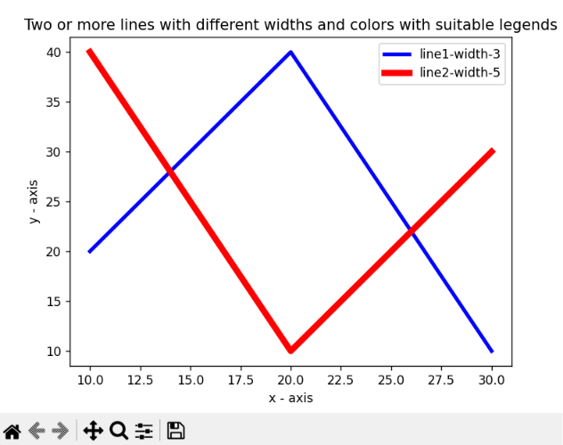
Result:
Thus, the Python program successfully plots two lines with different colors, line widths, and legends.

26. Create Multiple Plots Date:17-06-2026
Aim:
To write a Python program to create multiple plots using Matplotlib.
Algorithm:
- Start the program.
- Import matplotlib.pyplot.
- Create a figure.
- Divide the figure into multiple subplots using subplot().
- Plot data in each subplot.
- Display all plots using show().
- Stop the program.
Code:
import matplotlib.pyplot as plt

plt.subplot(2, 1, 1)
plt.plot([1, 2, 3, 4])

plt.subplot(2, 3, 4)
plt.plot([1, 2, 3])

plt.subplot(2, 3, 5)
plt.plot([3, 2, 1])

plt.subplot(2, 3, 6)
plt.plot([1, 3, 2])

plt.show()

Output:
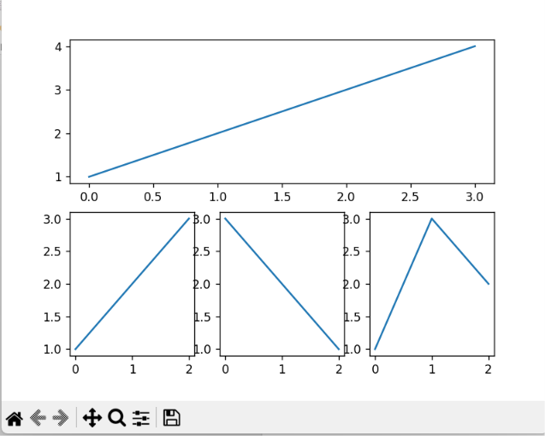
Result:
Thus, the Python program successfully creates multiple plots using subplots in a single figure.

27. Write a Python program to display a bar chart of the popularity of Programming Languages. Date:17-06-2026
Aim
To write a Python program to display a bar chart representing the popularity of different programming languages.
Algorithm
- Import the matplotlib.pyplot module.
- Create a list of programming languages.
- Create a list of popularity values.
- Use the bar() function to create a bar chart.
- Add chart title and axis labels.
- Display the chart using show().
- End the program.
Program
import matplotlib.pyplot as plt
languages = ['Java', 'Python', 'PHP', 'JavaScript', 'C#', 'C++']
popularity = [22.2, 17.6, 8.8, 8.0, 7.7, 6.7]
plt.bar(languages, popularity)
plt.title("Popularity of Programming Languages")
plt.xlabel("Programming Languages")
plt.ylabel("Popularity")
plt.show()
Output:
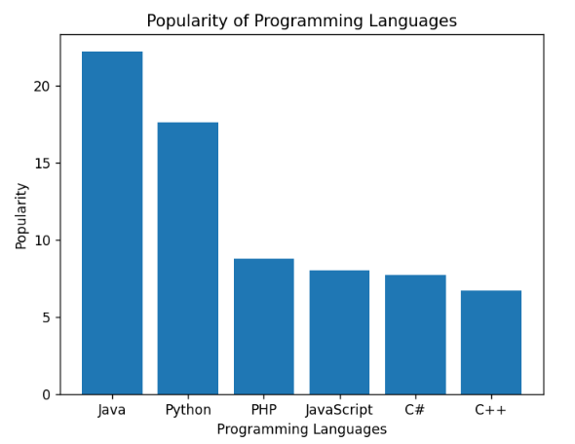
Result
Thus, the Python program to display a bar chart of the popularity of programming languages was executed successfully and the output was obtained.

28. Write a Python Program to Display a Horizontal Bar Chart of the Popularity of Programming Languages
Date: 17-06-2026
Aim
To write a Python program to display a horizontal bar chart representing the popularity of different programming languages.
Algorithm
- Import the matplotlib.pyplot module.
- Create a list of programming languages.
- Create a list of popularity values.
- Use the barh() function to create a horizontal bar chart.
- Add chart title and axis labels.
- Display the chart using show().
- End the program.
Program
import matplotlib.pyplot as plt
languages = ['Java', 'Python', 'PHP', 'JavaScript', 'C#', 'C++']
popularity = [22.2, 17.6, 8.8, 8.0, 7.7, 6.7]
plt.barh(languages, popularity)
plt.title("Popularity of Programming Languages")
plt.xlabel("Popularity (%)")
plt.ylabel("Programming Languages")
plt.show()
Output
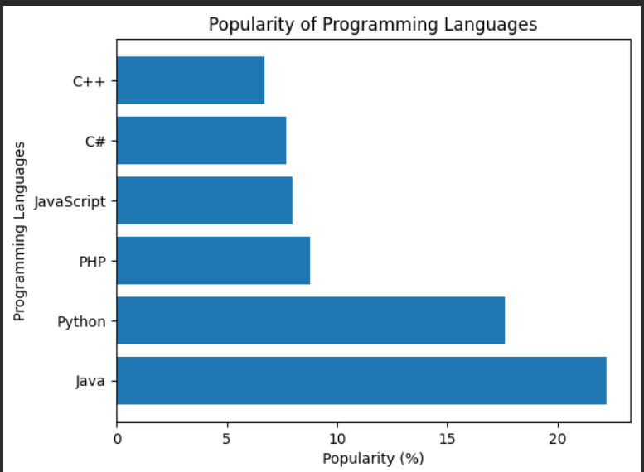
A horizontal bar chart displaying the popularity of programming languages.
Result
Thus, the Python program to display a horizontal bar chart of the popularity of programming languages was executed successfully and the output was obtained.

29. Write a Python Program to Display a Bar Chart of the Popularity of Programming Languages Using Different Colors
Date: 17-06-2026
Aim
To write a Python program to display a bar chart of programming languages using different colors for each bar.
Algorithm
- Import the matplotlib.pyplot module.
- Create a list of programming languages.
- Create a list of popularity values.
- Create a list of colors.
- Use the bar() function with the color parameter.
- Add chart title and axis labels.
- Display the chart.
- End the program.
Program
import matplotlib.pyplot as plt
languages = ['Java', 'Python', 'PHP', 'JavaScript', 'C#', 'C++']
popularity = [22.2, 17.6, 8.8, 8.0, 7.7, 6.7]
colors = ['red', 'blue', 'green', 'orange', 'purple', 'brown']
plt.bar(languages, popularity, color=colors)
plt.title("Popularity of Programming Languages")
plt.xlabel("Programming Languages")
plt.ylabel("Popularity (%)")
plt.show()
Output
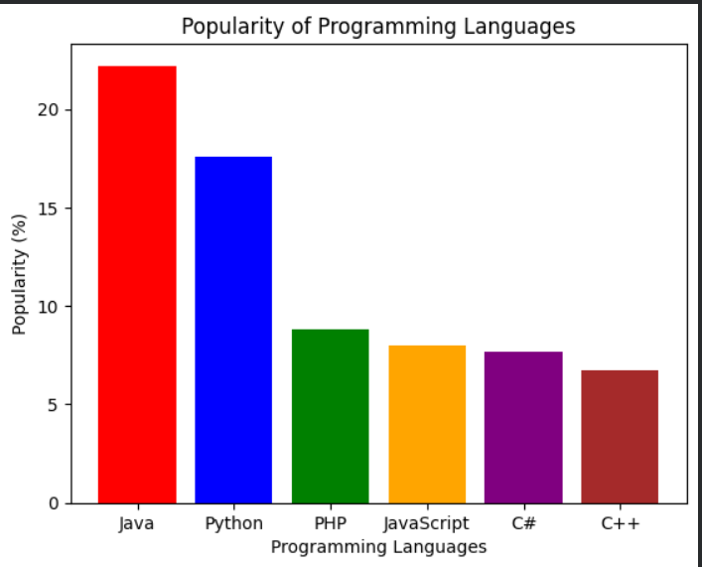
A bar chart displaying the popularity of programming languages with different colors for each bar.
Result
Thus, the Python program to display a bar chart with different colors for each programming language was executed successfully and the output was obtained.

30. Write a Python Program to Create a Bar Plot of Scores by Group and Gender
Date: 17-06-2026
Aim
To write a Python program to create a grouped bar chart showing scores of men and women for different groups.
Algorithm
- Import the required modules.
- Create data for men and women scores.
- Create positions for the bars.
- Plot bars for men and women side by side.
- Add title, labels, and legend.
- Display the chart.
- End the program.
Program
import matplotlib.pyplot as plt
import numpy as np
men_means = (22, 30, 35, 35, 26)
women_means = (25, 32, 30, 35, 29)
groups = ['G1', 'G2', 'G3', 'G4', 'G5']
x = np.arange(len(groups))
width = 0.35
plt.bar(x - width/2, men_means, width, label='Men')
plt.bar(x + width/2, women_means, width, label='Women')
plt.title("Scores by Group and Gender")
plt.xlabel("Groups")
plt.ylabel("Scores")
plt.xticks(x, groups)
plt.legend()
plt.show()
Output
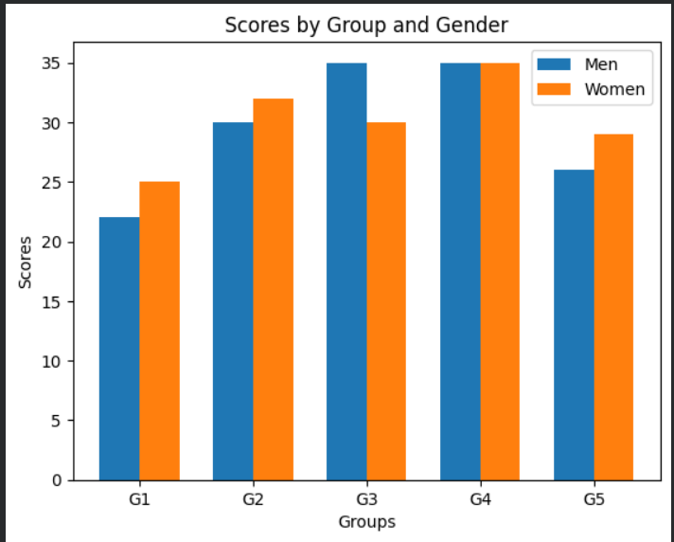
A grouped bar chart displaying scores of men and women for each group.
Result
Thus, the Python program to create a grouped bar chart of scores by group and gender was executed successfully and the output was obtained.

28. Write a Python program to display a horizontal bar chart of the popularity of Programming Languages. Date:18-06-2026
Aim
To write a Python program to display a horizontal bar chart representing the popularity of different programming languages.
Algorithm
- Import the matplotlib.pyplot module.
- Create a list of programming languages.
- Create a list of popularity values.
- Use the barh() function to create a horizontal bar chart.
- Add chart title and axis labels.
- Display the chart using show().
- End the program.
Program
import matplotlib.pyplot as plt
languages = ['Java', 'Python', 'PHP', 'JavaScript', 'C#', 'C++']
popularity = [22.2, 17.6, 8.8, 8.0, 7.7, 6.7]
plt.barh(languages, popularity)
plt.title("Popularity of Programming Languages")
plt.xlabel("Popularity")
plt.ylabel("Programming Languages")
plt.show()

Output:
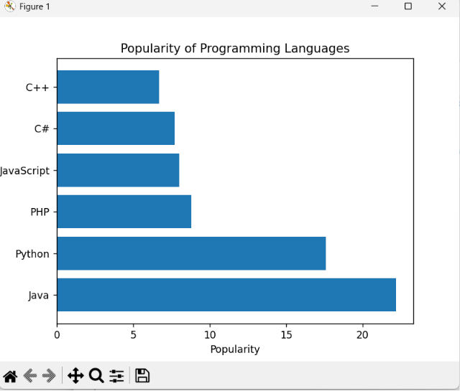
Result
Thus, the Python program to display a horizontal bar chart of the popularity of programming languages was executed successfully and the required output was obtained.

29. Write a Python program to display a bar chart of the popularity of Programming Languages using different colors for each bar. Date:18-06-2026
Aim
To write a Python program to display a bar chart of programming language popularity using different colors for each bar.
Algorithm
- Import the matplotlib.pyplot module.
- Create a list of programming languages.
- Create a list of popularity values.
- Create a list of colors for the bars.
- Use the bar() function with the color parameter.
- Add title and axis labels.
- Display the chart using show().
- End the program.
Program
import matplotlib.pyplot as plt
languages = ['Java', 'Python', 'PHP', 'JavaScript', 'C#', 'C++']
popularity = [22.2, 17.6, 8.8, 8.0, 7.7, 6.7]
colors = ['red', 'blue', 'green', 'orange', 'purple', 'brown']
plt.bar(languages, popularity, color=colors)
plt.title("Popularity of Programming Languages")
plt.xlabel("Programming Languages")
plt.ylabel("Popularity")
plt.show()

Output:

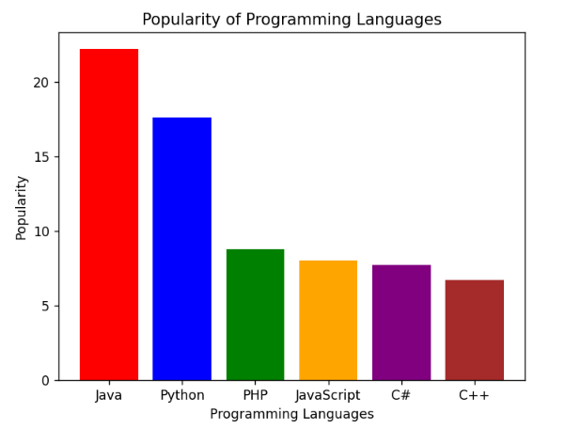

Result
Thus, the Python program to display a bar chart of the popularity of programming languages using different colors for each bar was executed successfully and the required output was obtained.

30. Write a Python program to create a bar plot of scores by group and gender using multiple X values on the same chart for men and women. Date:18-06-2026
Aim
To write a Python program to create a grouped bar chart showing scores of men and women for different groups.
Algorithm
- Import matplotlib.pyplot and numpy.
- Create arrays for men's and women's scores.
- Create positions for the groups on the X-axis.
- Set the width of each bar.
- Plot bars for men and women side by side.
- Add labels, title, and legend.
- Display the chart using show().
- End the program.
Program
import matplotlib.pyplot as plt
import numpy as np
men_means = (22, 30, 35, 35, 26)
women_means = (25, 32, 30, 35, 29)
groups = np.arange(5)
width = 0.35
plt.bar(groups, men_means, width, label='Men')
plt.bar(groups + width, women_means, width, label='Women')
plt.xlabel('Groups')
plt.ylabel('Scores')
plt.title('Scores by Group and Gender')
plt.xticks(groups + width/2, ('G1', 'G2', 'G3', 'G4', 'G5'))
plt.legend()
plt.show()

Output:
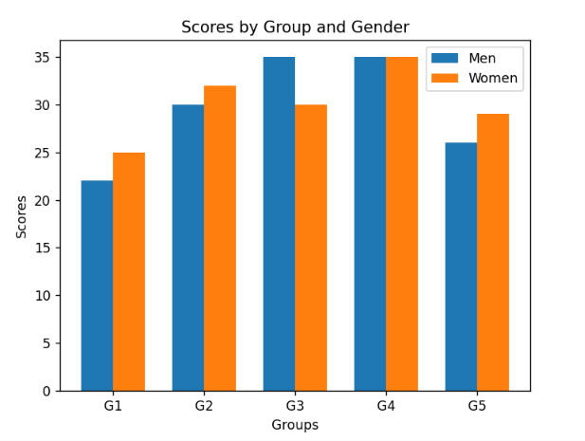
Result
Thus, the Python program to create a grouped bar chart of scores by group and gender was executed successfully and the required output was obtained.

31. Write a Python program to create a stacked bar plot with error bars.
Date: 21-06-2026
Aim
To write a Python program to create a stacked bar chart with error bars for men and women scores.
Algorithm
- Import matplotlib.pyplot and numpy.
- Create data for men and women means and standard deviations.
- Create positions for groups.
- Plot men's bars with error bars.
- Plot women's bars above men's bars using the bottom parameter.
- Add labels, title, and legend.
- Display the chart.
- End the program.
Sample input:
import matplotlib.pyplot as plt
import numpy as np

men_means = (22, 30, 35, 35, 26)
women_means = (25, 32, 30, 35, 29)

men_std = (4, 3, 4, 1, 5)
women_std = (3, 5, 2, 3, 3)

ind = np.arange(5)

plt.bar(ind, men_means, yerr=men_std, label='Men')
plt.bar(ind, women_means, bottom=men_means,
yerr=women_std, label='Women')

plt.xlabel('Groups')
plt.ylabel('Scores')
plt.title('Stacked Bar Plot with Error Bars')
plt.xticks(ind, ('G1','G2','G3','G4','G5'))
plt.legend()

plt.show()

output:

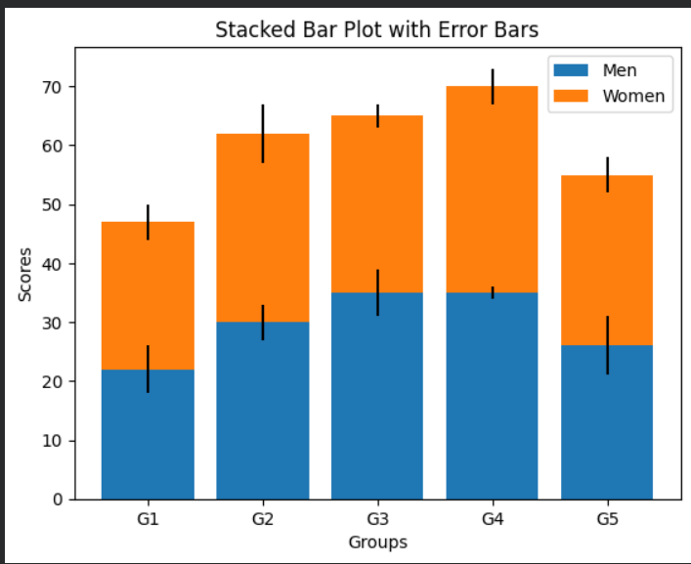

Result
Thus, the Python program to create a stacked bar chart with error bars was executed successfully and the required output was obtained.

32. Write a Python program to draw a scatter graph taking a random distribution in X and Y and plotted against each other.
Date: 21-06-2026
Aim
To draw a scatter graph using random distributions for X and Y values.
Algorithm
- Import matplotlib.pyplot and numpy.
- Generate random X and Y values.
- Plot the scatter graph.
- Add title and labels.
- Display the graph.
- End the program.
Program
import matplotlib.pyplot as plt
import numpy as np
x = np.random.rand(50)
y = np.random.rand(50)
plt.scatter(x, y)
plt.xlabel("X Values")
plt.ylabel("Y Values")
plt.title("Random Scatter Plot")
plt.show()
Output
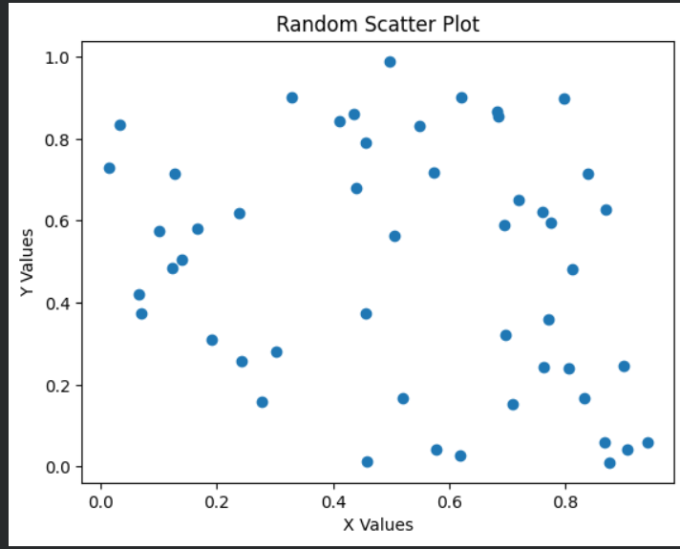
A scatter plot with 50 randomly distributed points.
Result
Thus, the Python program to draw a random scatter graph was executed successfully.

33. Write a Python program to draw a scatter plot with empty circles taking a random distribution in X and Y and plotted against each other.
Date: 21-06-2026
Aim
To draw a scatter plot using empty circle markers.
Algorithm
- Import matplotlib.pyplot and numpy.
- Generate random X and Y values.
- Use scatter() with hollow circles.
- Display the graph.
- End the program.
Program
import matplotlib.pyplot as plt
import numpy as np
x = np.random.rand(50)
y = np.random.rand(50)
plt.scatter(x, y, facecolors='none', edgecolors='black')
plt.title("Scatter Plot with Empty Circles")
plt.show()
Output
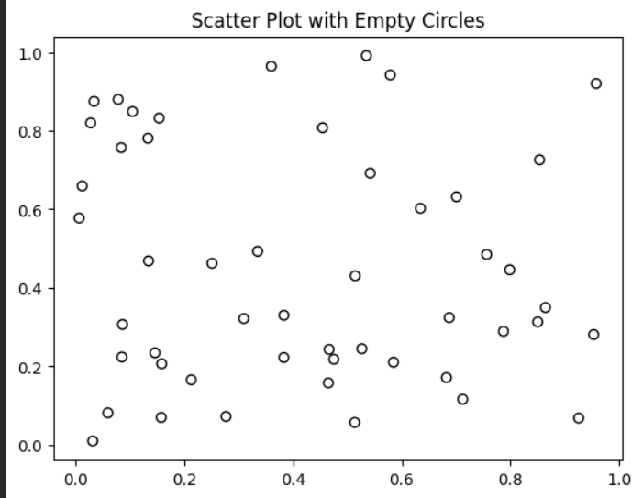
A scatter plot containing hollow circle markers.
Result
Thus, the Python program to draw a scatter plot with empty circles was executed successfully.

34. Write a Python program to draw a scatter plot using random distributions to generate balls of different sizes.
Date: 21-06-2026
Aim
To create a scatter plot with points of varying sizes.
Algorithm
- Import matplotlib.pyplot and numpy.
- Generate random X and Y values.
- Generate random sizes.
- Plot scatter graph using size values.
- Display graph.
- End the program.
Program
import matplotlib.pyplot as plt
import numpy as np
x = np.random.rand(50)
y = np.random.rand(50)
sizes = np.random.randint(50, 500, 50)
plt.scatter(x, y, s=sizes)
plt.title("Scatter Plot with Different Ball Sizes")
plt.show()
Output
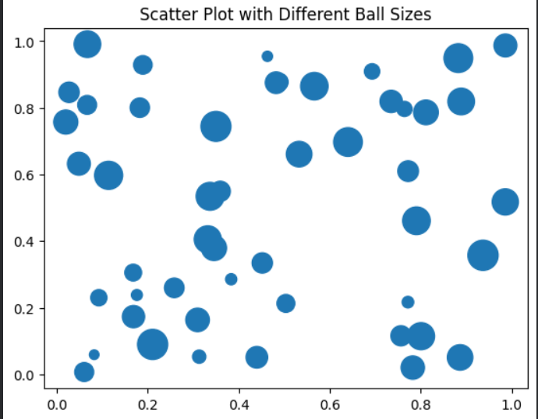
A scatter plot with points of different sizes.
Result
Thus, the Python program to draw a scatter plot with varying ball sizes was executed successfully.

35. Write a Python program to draw a scatter plot comparing Mathematics and Science marks.
Date: 21-06-2026
Aim
To compare Mathematics and Science marks using a scatter plot.
Algorithm
- Import matplotlib.pyplot.
- Create Mathematics and Science marks lists.
- Plot scatter graph.
- Add labels and title.
- Display graph.
- End the program.
Program
import matplotlib.pyplot as plt
math_marks = [88,92,80,89,100,80,60,100,80,34]
science_marks = [35,79,79,48,100,88,32,45,20,30]
plt.scatter(math_marks, science_marks)
plt.xlabel("Math Marks")
plt.ylabel("Science Marks")
plt.title("Math vs Science Marks")
plt.show()
Output
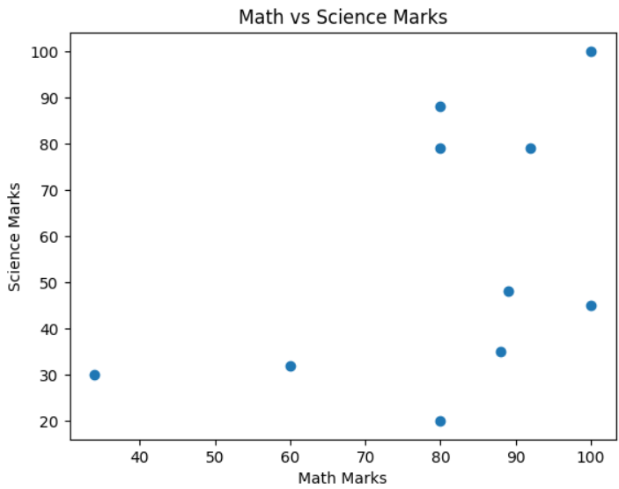
A scatter plot showing the relationship between Mathematics and Science marks of 10 students.
Result
Thus, the Python program to compare Mathematics and Science marks using a scatter plot was executed successfully.

36. Write a Python program to draw a scatter plot for three different groups comparing weights and heights.
Date: 21-06-2026
Aim
To compare heights and weights of three groups using scatter plots.
Algorithm
- Import matplotlib.pyplot.
- Create height and weight data for three groups.
- Plot scatter graphs for each group.
- Add labels, title, and legend.
- Display graph.
- End the program.
Program
import matplotlib.pyplot as plt
height1 = [150,160,170,180]
weight1 = [50,60,70,80]
height2 = [155,165,175,185]
weight2 = [55,65,75,85]
height3 = [158,168,178,188]
weight3 = [58,68,78,88]
plt.scatter(height1, weight1, label='Group 1')
plt.scatter(height2, weight2, label='Group 2')
plt.scatter(height3, weight3, label='Group 3')
plt.xlabel("Height")
plt.ylabel("Weight")
plt.title("Height vs Weight Comparison")
plt.legend()
plt.show()
Output
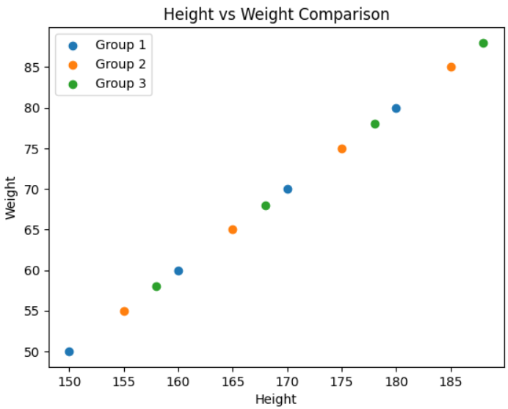
A scatter plot showing three groups with different markers.
Result
Thus, the Python program to compare heights and weights of three groups was executed successfully.

Question 37
Aim
To create a Pandas DataFrame from a dictionary and display it.
Algorithm
1. Import the Pandas library.
2. Create a dictionary with the given values.
3. Convert the dictionary into a DataFrame.
4. Display the DataFrame.
Code
import pandas as pd
data = {
'X':[78,85,96,80,86],
'Y':[84,94,89,83,86],
'Z':[86,97,96,72,83]
}
df = pd.DataFrame(data)
print(df)
Result
X Y Z
0 78 84 86
1 85 94 97
2 96 89 96
3 80 83 72
4 86 86 83

Question 38
Aim
To create and display a DataFrame from a specified dictionary with index labels.
Algorithm
1. Import Pandas and NumPy libraries.
2. Create the dictionary and labels list.
3. Create the DataFrame using the labels as index.
4. Display the DataFrame.
Code
import pandas as pd
import numpy as np
exam_data = {
'name':['Anastasia','Dima','Katherine','James','Emily',
'Michael','Matthew','Laura','Kevin','Jonas'],
'score':[12.5,9,16.5,np.nan,9,20,14.5,np.nan,8,19],
'attempts':[1,3,2,3,2,3,1,1,2,1],
'qualify':['yes','no','yes','no','no','yes','yes','no','no','yes']
}
labels=['a','b','c','d','e','f','g','h','i','j']
df = pd.DataFrame(exam_data,index=labels)
print(df)
Result
The DataFrame with custom index labels was displayed successfully.
Question 39
Aim
To display the first three rows of a DataFrame.
Algorithm
1. Import Pandas and NumPy libraries.
2. Create the DataFrame.
3. Use head(3) method to retrieve the first three rows.
4. Display the output.
Code
print(df.head(3))
Result
name score attempts qualify
a Anastasia 12.5 1 yes
b Dima 9.0 3 no
c Katherine 16.5 2 yes
Question 40
Aim
To select and display the 'name' and 'score' columns from a DataFrame.
Algorithm
1. Import Pandas and NumPy libraries.
2. Create the DataFrame.
3. Select the required columns.
4. Display the selected columns.
Code
print(df[['name','score']])
Result
name score
a Anastasia 12.5
b Dima 9.0
c Katherine 16.5
d James NaN
e Emily 9.0
f Michael 20.0
g Matthew 14.5
h Laura NaN
i Kevin 8.0
j Jonas 19.0

